**Water-level detect and alarm**

**Components**

|  |  |
| --- | --- |
|  |  |

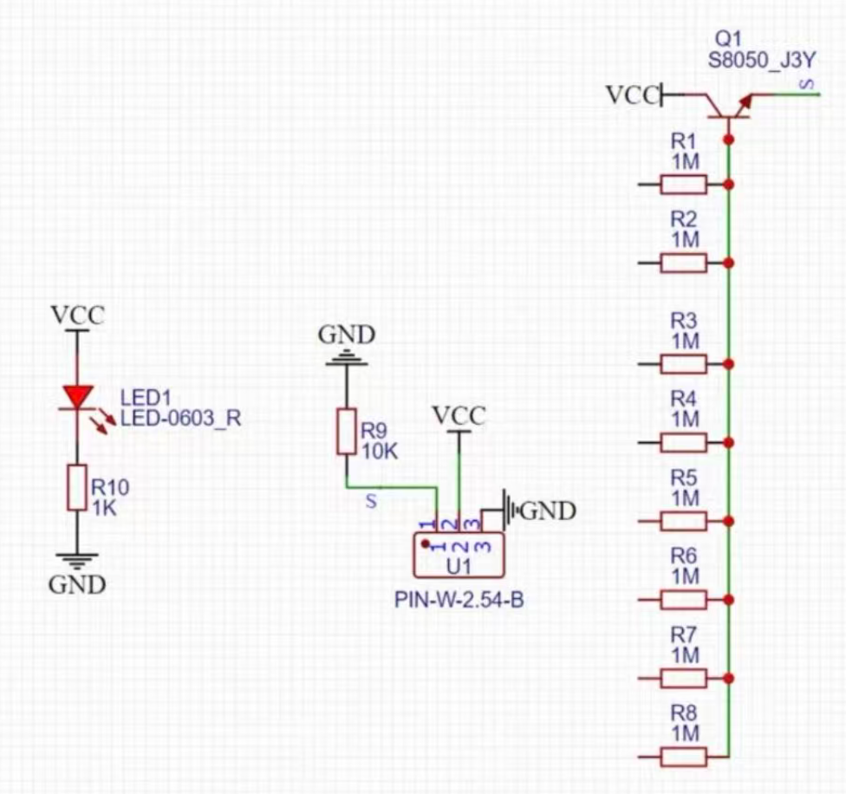

Schematic of Water Level Sensor

**System Block Diagram**

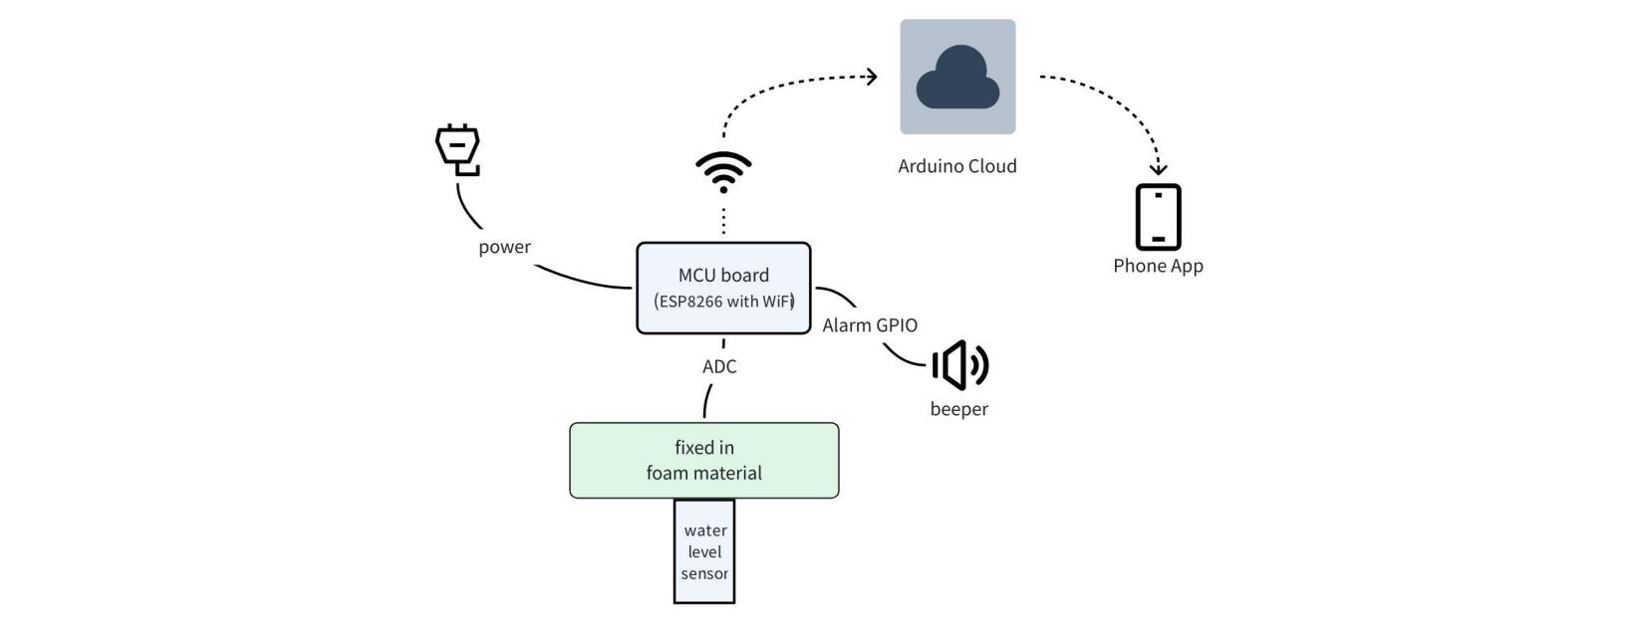

**Source Code**

|  |
| --- |
| waterlevel.ino #include <dummy.h>  /*   Sketch generated by the Arduino IoT Cloud Thing "Untitled"  https://create.arduino.cc/cloud/things/97fc0c47-9106-4a95-a9b1-bbf57d836ae9    Arduino IoT Cloud Variables description   The following variables are automatically generated and updated when changes are made to the Thing   int water_level;   Variables which are marked as READ/WRITE in the Cloud Thing will also have functions  which are called when their values are changed from the Dashboard.  These functions are generated with the Thing and added at the end of this sketch. */  #include "thingProperties.h"  #define ALRAM_GPIO 4 //labled as D2 #define BEEP_ON digitalWrite(ALRAM_GPIO, HIGH) #define BEEP_OFF digitalWrite(ALRAM_GPIO, LOW)  void setup() {  // Initialize serial and wait for port to open:  Serial.begin(9600);  // This delay gives the chance to wait for a Serial Monitor without blocking if none is found  delay(1500);   // Defined in thingProperties.h  initProperties();  // Connect to Arduino IoT Cloud  ArduinoCloud.begin(ArduinoIoTPreferredConnection);    /*  The following function allows you to obtain more information  related to the state of network and IoT Cloud connection and errors  the higher number the more granular information you’ll get.  The default is 0 (only errors).  Maximum is 4  */  setDebugMessageLevel(2);  ArduinoCloud.printDebugInfo();   //a short beep at startup  pinMode(ALRAM_GPIO, OUTPUT);  BEEP_ON;  delay(100);  BEEP_OFF; }  const int ADC_pin = A0; // Define the ADC pin int normal_mode = 1;  void loop() {  ArduinoCloud.update();  water_level = analogRead(ADC_pin); // Read the analog value  Serial.print("ADC Value: ");  Serial.println(water_level); // Print the value to Serial Monitor   normal_mode = water_level < 80;   if (normal_mode)  delay(1000); // Delay for readability  else {  Serial.println("ALARM!!!");  BEEP_ON;  delay(500);  BEEP_OFF;  delay(500);  } } |

**Arduino Official App**

|  |  |  |
| --- | --- | --- |
|  |  |  |